**Mid Term Project Summary**

**Name: Shyam G. Pradhan**

**Roll No: A76**

**Reg No: 2018bcs509**

**1. Information Gathering**

Following are outputs of surveys we did before start working on project. For survey we asked following question to the grocery shop owner. For survey, we visited to 5 local grocery shop.

1. **How grocery shop sells their products?**

Local grocery shops don’t have any delivery system. Customer physically need to go to grocery shop to buy the groceries they want. We come to know that local grocery shops have customer in 2km. circle.

1. **How they manage their inventory?**

Some of grocery shops have their godown (Small Warehouse). They normally use book to manage product they have. Whenever the stock of some product is less, they order the same from different vendors. For that they have list of their merchants.

1. **How they manage customers information?**

Usually, the grocery shop doesn’t use to have any information about the customer.

1. **Did they used online way to sell their products in pandemic?**

Lots of grocery shop don’t use to have their business on internet. But some of them sell their product on WhatsApp or on mobile phone. These shops also have home delivery. For that they have hired delivery boy to deliver the products. For home delivery they are taking some cost.

So, this is information that we have gathered in our survey. This information really helps us to build our initial project model.

**2. Conceptual diagram of project.**

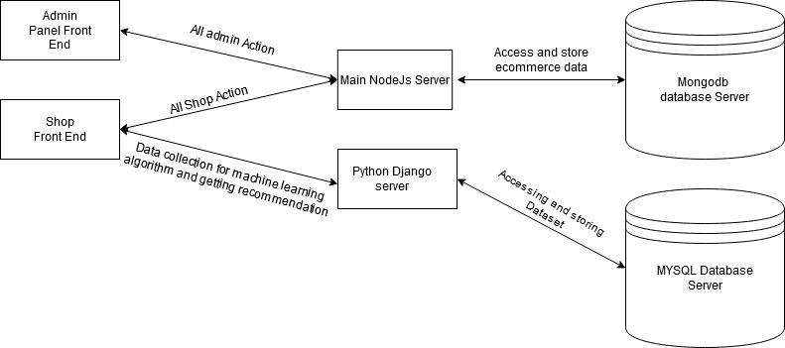

This is conceptual diagram of project. There are mainly three parts in it,

1. Front End
2. Servers
3. Database Servers

**Front End:** In the front end I am using ReactJS. This is web project so the html and CSS would be there. There are two parts of front end, first is Admin Panel which handles all operation of shopkeeper. It consists Management of product, Inventory, Orders Modules. And second module is for customer side. The basic task of this is to provide all e commerce features.

**Servers:** The next thing is server, I am using NODEJS for performing all the task of managing the ecommerce functions. And the DJANGO is for Recommending the product. As it uses a python, it is convenient to use for Machine Learning algorithms.

**Database Servers:** for storing the data I am using both relational and non-relational databases. For general storing of data, I am using MongoDB and for searching keywords and for recommendation system I am using MYSQL database.

**3. Technology Stack**

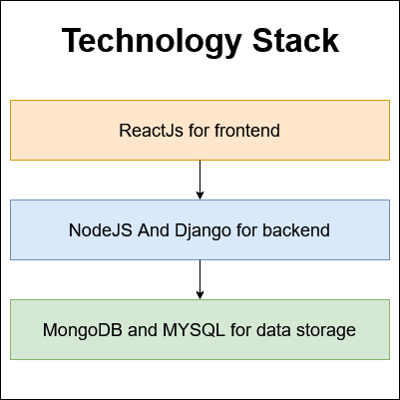

**4. Admin Panel Screenshots and Explanations.**

**4.1 Login Window**

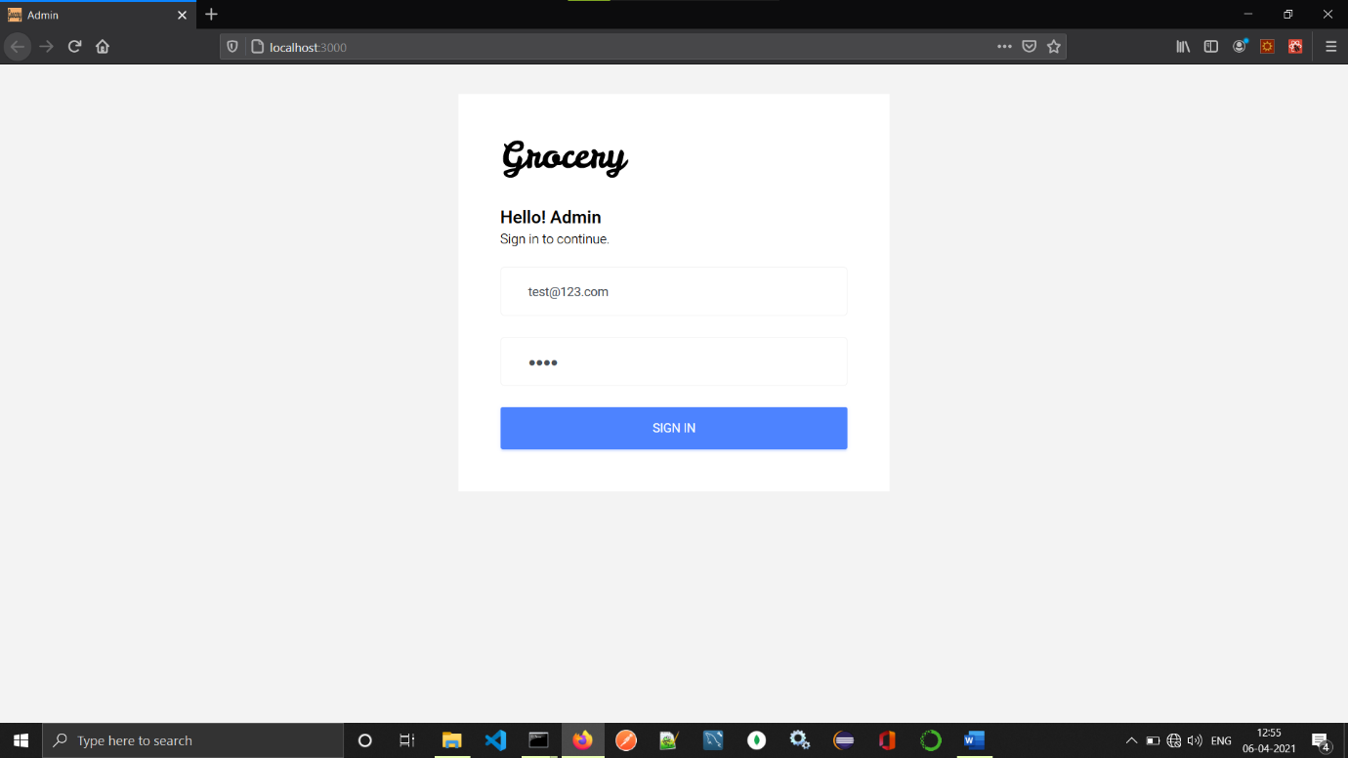

This is login window for admin. It requires registered admin email and password.

* 1. **Dashboard**

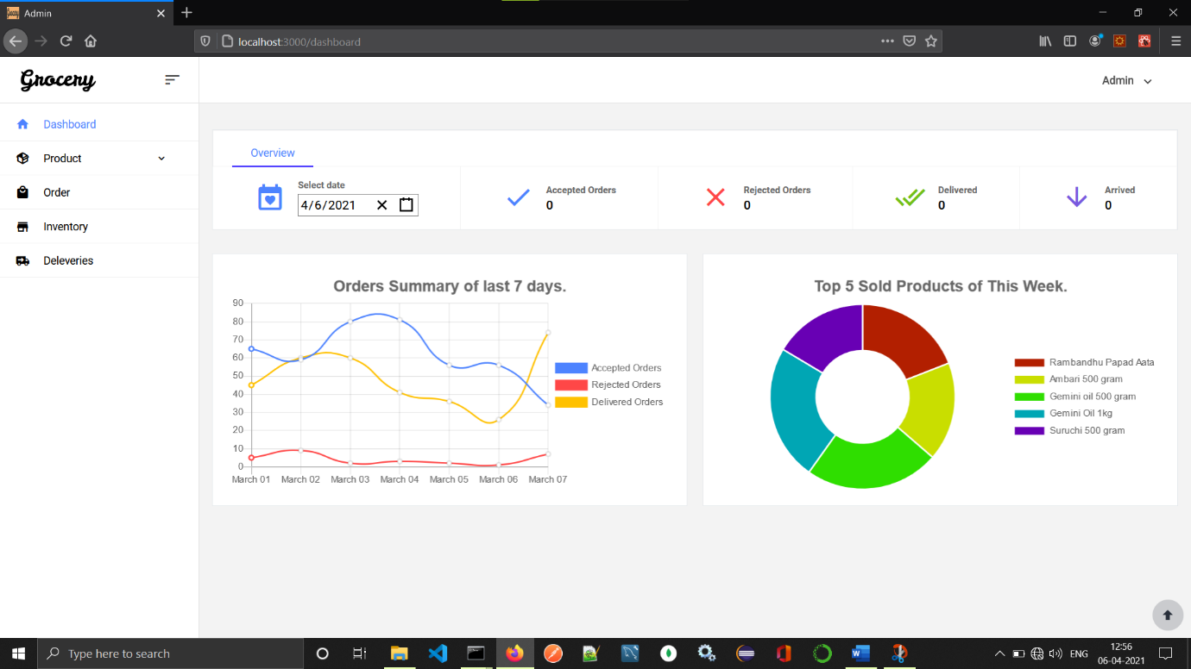

This is Dashboard of admin panel. It mainly consists pie chart line chart and the date wise report catalog. In Overview menu we can see the information about todays orders. It shows number of accepted orders, Rejected Orders, Delivered Orders, And Arrived Orders. And next is graph component it shows summary of last seven days in graphical manner.

* 1. **Add Product Form**

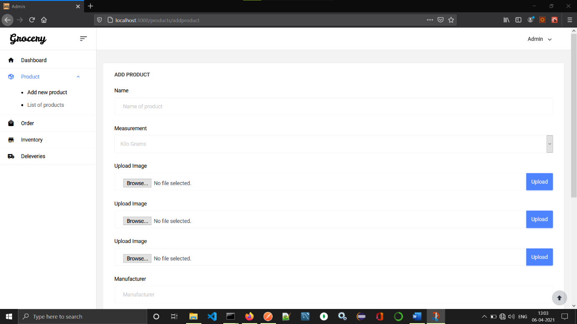

Add product form will use for adding new product in shop. In this project the product has following attributes, Name, Measurement, Images, Manufacturer, Keywords, Category. Plus we are having autogenerated id for each product.

* 1. **List of Products**

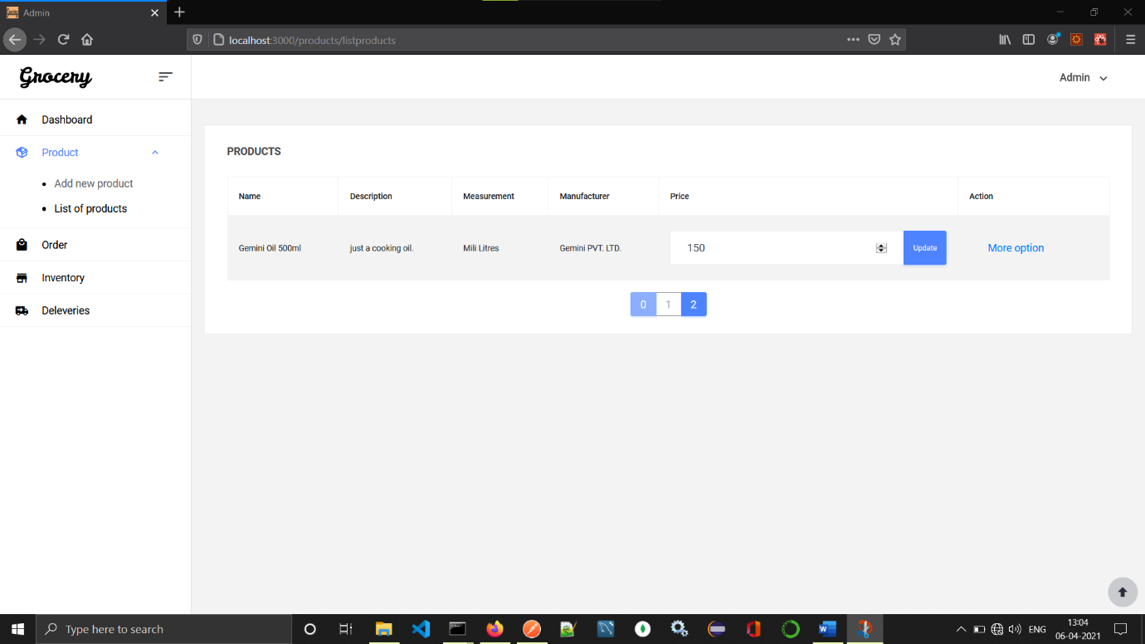

It has List of products form this list one can edit the price of product and even edit the product by clicking more option button.

* 1. **Edit Product Form**

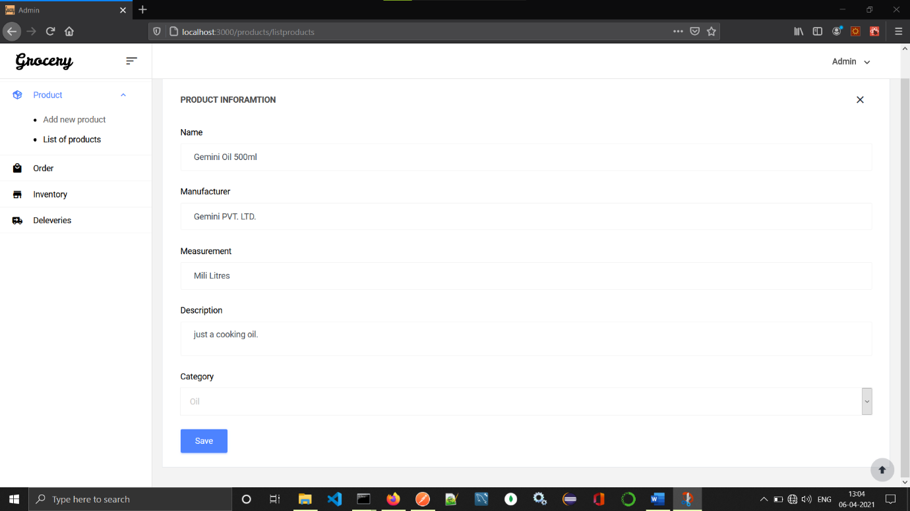

After clicking more options from list, we will get this form in which we can see the information of it. And product information can be edited from this form.

* 1. **List of Orders**

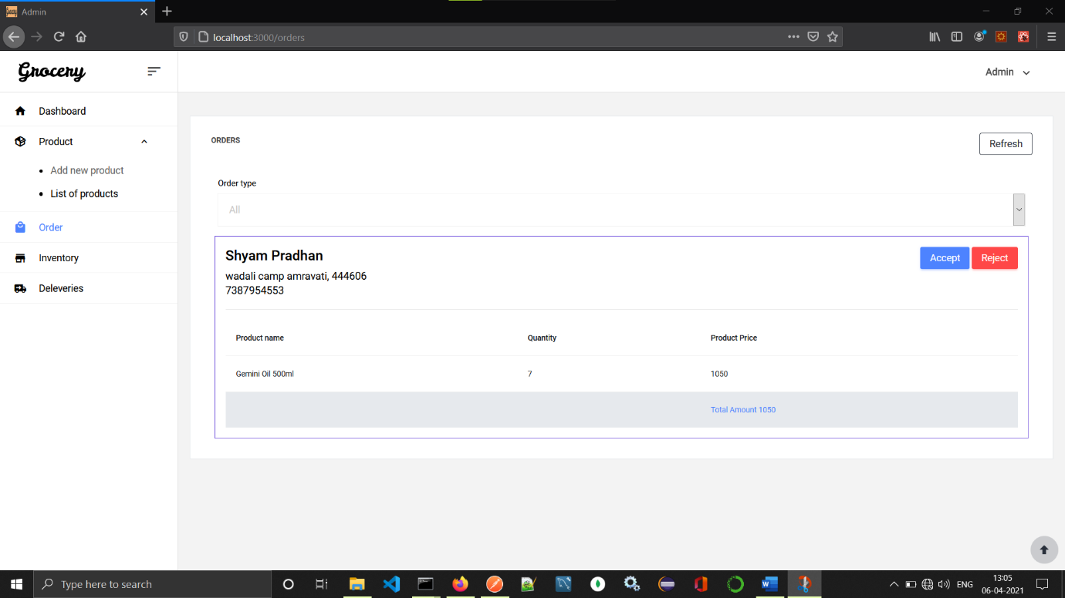

This page consists list of all the todays orders. Order having different status like, Arrived, Being Delivered, Rejected, Delivered. From this admin can accept reject order or even track the orders. It also consist the filter which allow admin to filter orders.

* 1. **Inventory**

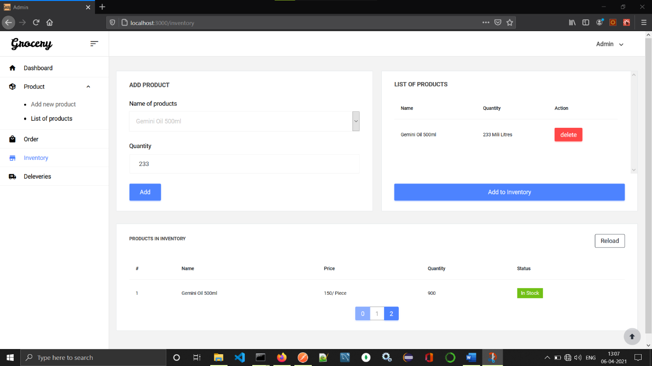

Adding new items to inventory can be handle by this module. It shows status of each product whether it is in stock or not is provided by this module.

* 1. **Deliveries**

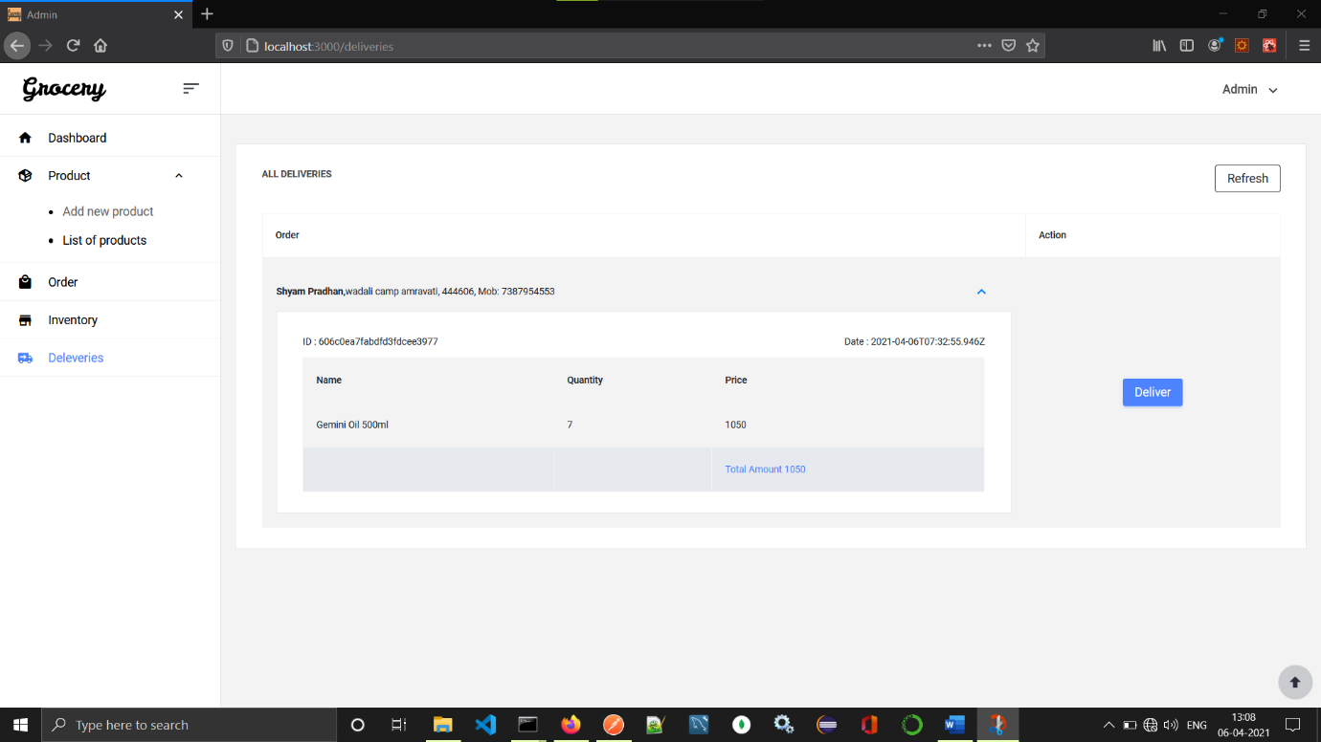

This page mainly shows the deliveries that has to delivered to customer. Deliver button will be clicked when item is delivered successfully to the customer.

**5. Customer Site**

**5.1 Home Page**

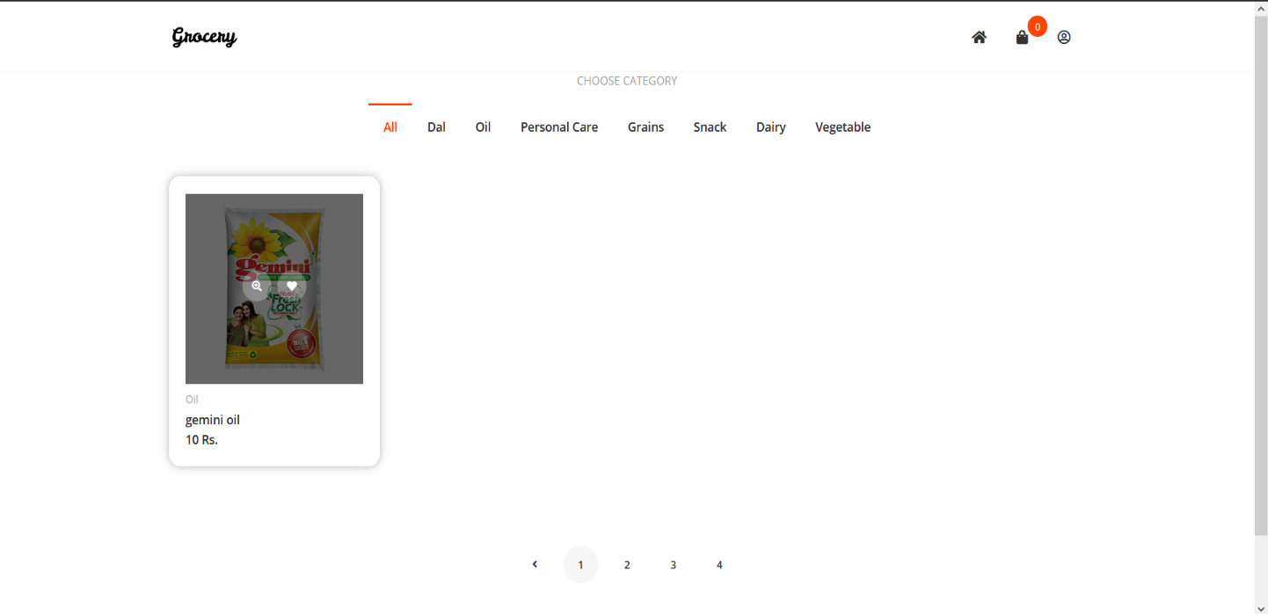

This is homepage for the shop. This mainly consists list of the products. And one can search product and it also consist category from which customer can search products.

**5.2 Add to Cart**

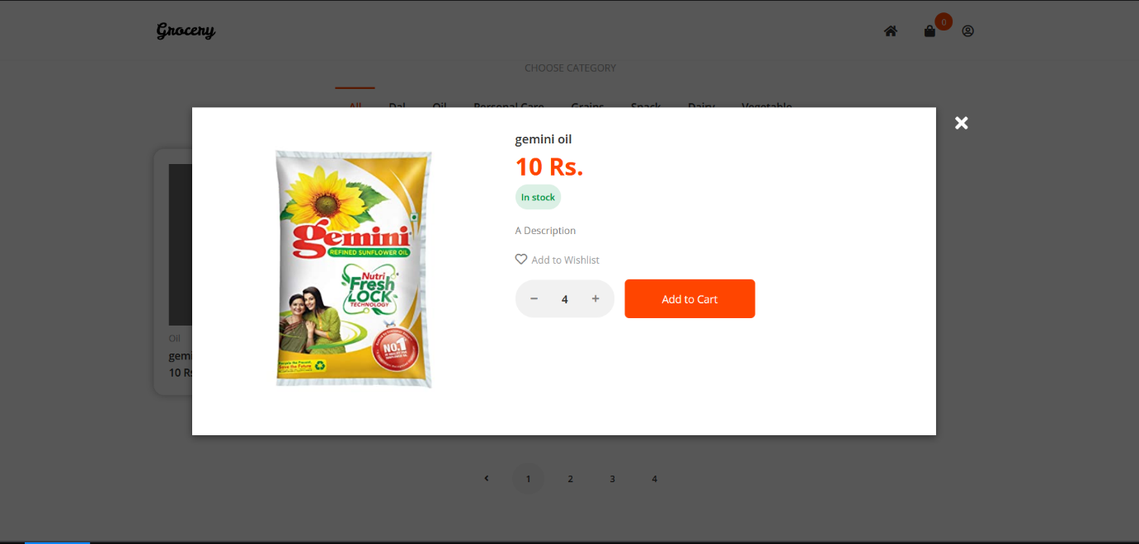

This popup shows description of product name of product and add cart button. Add to cart button will add this product to cart with quantity and same will be shown in checkout.

**5.3 Shopping Cart**

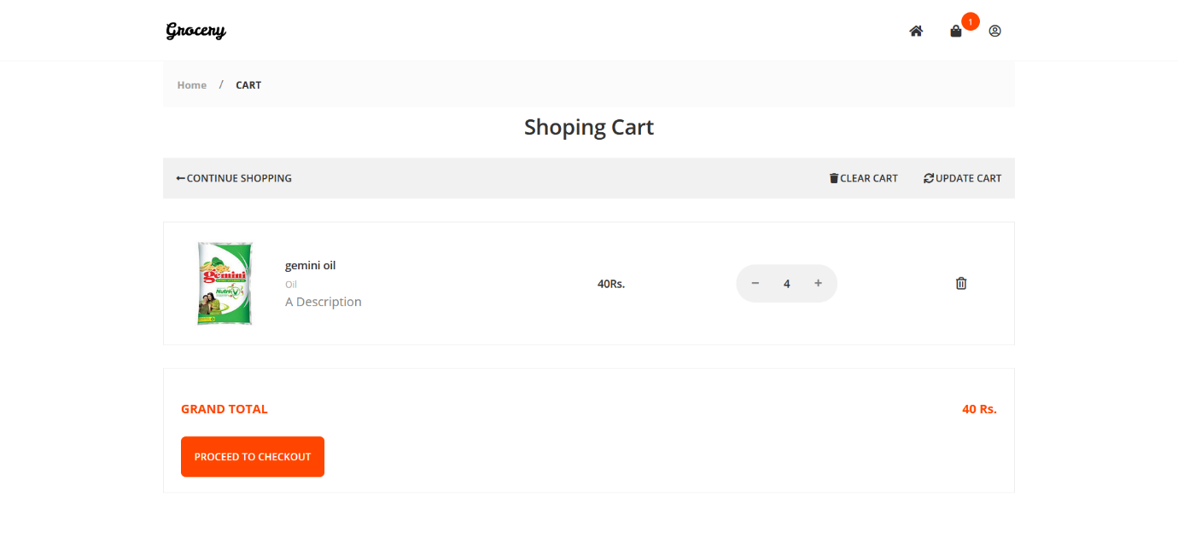

This page will consist list of the product in the cart. From which cart can be updated and cart can be cleared. From this page quantity of product in cart can be updated. And finally we can see the grand total. It has button for going to checkout page.

**5.4 Checkout**

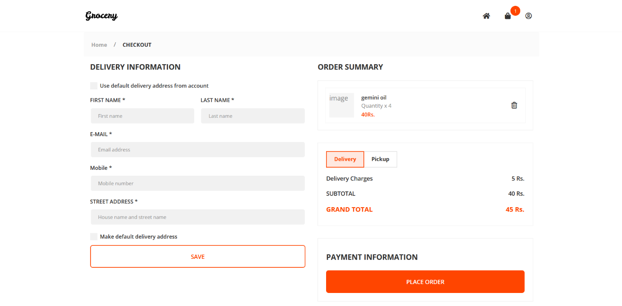

This is checkout page which consist the address info and user info in one side which will previously loaded (Not Completed). And in right side we can again see the list of products in cart we can also delete the product in checkout. Now user needs to choose delivery or pickup option delivery will add extra charges of deliver and pickup don’t have any.

**5.5 My Account**

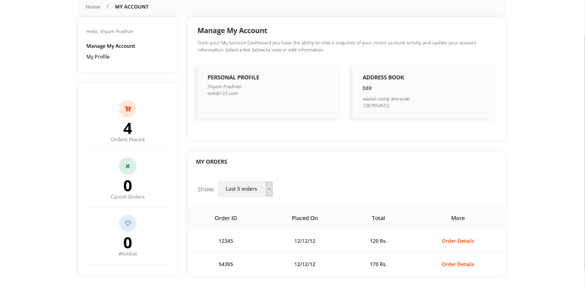

This page consists account info such name and address also it has list of orders thar are placed before. It also gives summary of orders in left side.

**5.6 Order Details**

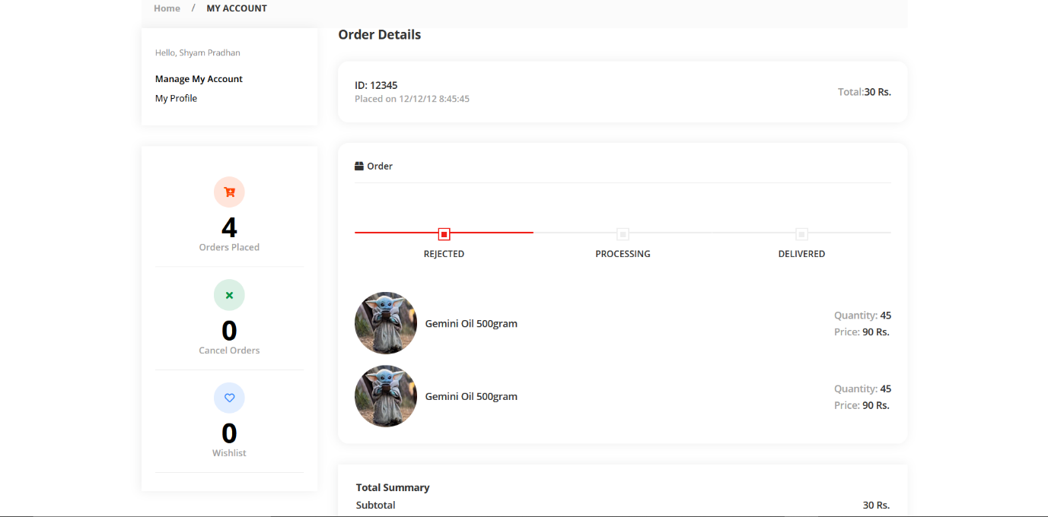

This is order details page which has info about the orders by clicking order details button in list we can get to it. Progress bar is given to show progress of orders.

**5.7 My Profile**

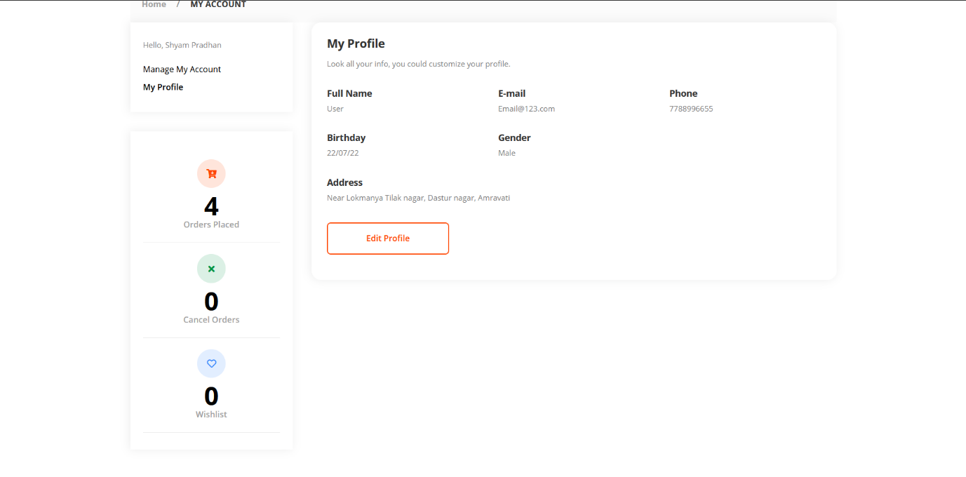

This is My Profile which consists basic information about profile can also be edited from this page.